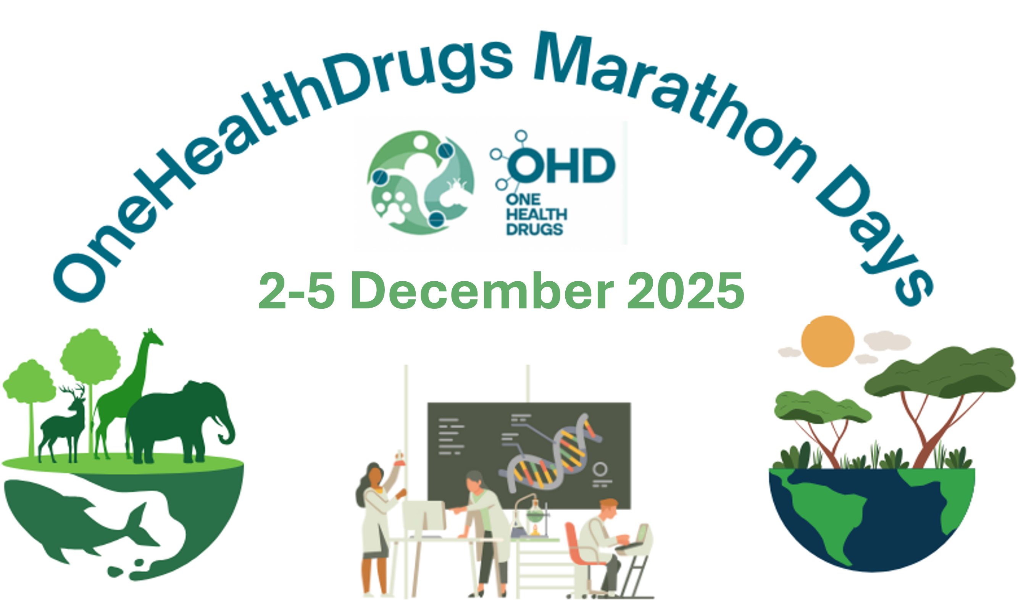
OneHealthdrugs MARATHON DAYS
2-5 December 2025
Organized by Gülşah Bayraktar and Anabela Cordeiro da Silva, Elisa Uliassi, Maria Paola Costi
Invitation to the OneHealthdrugs Marathon 2025: Fostering One Health Collaboration

We are excited to invite you to join us for the OneHealthdrugs Marathon, a series of non-stop online presentations and discussions taking place from December 2-5, 2025.

The One Health approach recognizes the fundamental interconnectedness of human, animal, and ecosystem health. By fostering collaboration across diverse sectors, we can more effectively address global health challenges, ranging from zoonotic diseases to critical environmental issues. This global initiative underscores the synergy required to achieve optimal health outcomes for all.
Through the EU COST Action OneHealthdrugs (CA21111), we are committed to revolutionizing drug development. Our focus is on innovating drug discovery to ensure precise actions and the early assessment of environmental impact, ultimately leading to optimal drug profiles that align with the One Health paradigm.
The OneHealthdrugs Marathon offers a unique platform to:
Share Research: All network participants are invited to present their latest research, enriching our collective understanding of the diverse research landscape within the network.
Attract New Talent: Provide an engaging environment to attract and welcome new applicants to our growing network.
Building Community: Foster a positive atmosphere of open collaboration and knowledge exchange among peers.
Integrate Innovation: Facilitate the integration of new concepts and innovative technologies into ongoing research programs through potential collaborations, training schools, and STSM-COST Action fellowships.

Join us for this inspiring 4-day marathon of insightful presentations, expert opinions, and invaluable opportunities to connect with fellow researchers and innovators who are passionate about health and sustainability. Together, we can drive significant advancements and make a tangible difference in our communities and beyond.
We look forward to your participation!

The deadline for registration and abstract submission is 26 November 2025.
Registration link:
https://docs.google.com/forms/d/e/1FAIpQLSfqldzVj5sskEZMHp6gCqCBD5ILx0Obvl-sSWbVawzMo38gXw/viewform?usp=publish-editor

Program
02.12.2025
14:30-18:00 CET
https://teams.microsoft.com/l/meetup-join/19%3aJdu4-YOGoTWvm2EtTXTcbi08m9LpmYFMY_vTAu_mQGU1%40thread.tacv2/1762122603736?context=%7b%22Tid%22%3a%22e787b025-3fc6-4802-874a-9c988768f892%22%2c%22Oid%22%3a%22ac391189-1971-4664-9abf-5dbf09f2a671%22%7d

Structural biology and Medicinal chemistry (including Natural products)
Moderators: Ulrike Wittig and Theodora Calogeropolou

03.12.2025
9.30-12.30 CET
https://teams.microsoft.com/l/meetup-join/19%3aJdu4-YOGoTWvm2EtTXTcbi08m9LpmYFMY_vTAu_mQGU1%40thread.tacv2/1762122757395?context=%7b%22Tid%22%3a%22e787b025-3fc6-4802-874a-9c988768f892%22%2c%22Oid%22%3a%22ac391189-1971-4664-9abf-5dbf09f2a671%22%7d

Integration of Ecotoxicology in drug discovery
Moderators: Harry de Koning and Lorenzo Raffellini

04.12.2025
14:30-18:00 CET
https://teams.microsoft.com/l/meetup-join/19%3aJdu4-YOGoTWvm2EtTXTcbi08m9LpmYFMY_vTAu_mQGU1%40thread.tacv2/1762122862735?context=%7b%22Tid%22%3a%22e787b025-3fc6-4802-874a-9c988768f892%22%2c%22Oid%22%3a%22ac391189-1971-4664-9abf-5dbf09f2a671%22%7d

YRI presentations + STSM presentations & @13:00 Awards
YRI are all collected on mixed subject reference Elisa Uliassi elisa.uliassi@unibo.it
Moderators: Elisa Uliassi and Gülşah Bayraktar

05.12.2025
9.30-12.30 CET
https://teams.microsoft.com/l/meetup-join/19%3aJdu4-YOGoTWvm2EtTXTcbi08m9LpmYFMY_vTAu_mQGU1%40thread.tacv2/1762122949003?context=%7b%22Tid%22%3a%22e787b025-3fc6-4802-874a-9c988768f892%22%2c%22Oid%22%3a%22ac391189-1971-4664-9abf-5dbf09f2a671%22%7d

Parasitology and pharmacology and One Health
Moderators: Guy Caljon and Nuno Santarem

On-line on Teams Platform
Select your SUBJECT AREA:
- Drug design & structural biology
- Medicinal Chemistry including (Natural products)
- Omics technologies
- Parasitology
- Ecotoxicology
- Pharmacology
- Integration of one health concepts

YRI and STSM fellows will present on 4 December 2025 - 14:30-18:00 CET (mixed subject) reference Elisa Uliassi elisa.uliassi@unibo.it

ABSTRACT TEMPLATE
Filename and subject of the e-mail when submitting (example): mario.rossi_parasitology

Title Abstract
Subject area:
Authors: Rossi Nx, ª Bib B.ª, etc
ª University of , Country; ^{b} University of , Country etc.
e-mail presenter

300 words maximum (1 page)
Calibri 11

1 small picture (facultative)
References
[1] ref, etc

Acknowledgment
The Authors acknowledge xxxx for the financial support.

Abstract submission deadline: 28 November 2025
Please, send your abstract to:
Anabela Cordeiro Da Silva e-mail cordeiro@ibmc.up.pt
Gülşah Bayraktar e-mail: bayraktargulsah@gmail.com
Elisa Ulassi: elisa.uliassi@unibo.it

For more info visit: https://onehealthdrugs.com/events/scientific-meeting/next-meeting/ohd-marathon-days-2-5-december-2025/

